# Data Sources

|  |  |
| --- | --- |
| Data | Source |
| Coid19 Spread country wise for each date | <https://www.ecdc.europa.eu/sites/default/files/documents/COVID-19-geographic-disbtribution-worldwide.xlsx> |
| Lockdown data | <https://en.wikipedia.org/wiki/National_responses_to_the_2019%E2%80%9320_coronavirus_pandemic> |
| WHO regions and Income group for each country | [https://apps.who.int/gho/athena/data/GHO/WHS9_86,WHS9_88,WHS9_89,WHS9_92,WHS9_96,WHS9_97,WHS9_90?filter=COUNTRY:*;REGION:*&amp;format=xml&amp;profile=excel](https://apps.who.int/gho/athena/data/GHO/WHS9_86,WHS9_88,WHS9_89,WHS9_92,WHS9_96,WHS9_97,WHS9_90?filter=COUNTRY:*;REGION:*&amp;format=xml&amp;profile=excel) |
| Country ISO3 Codes and Flag icons | <https://en.wikipedia.org/wiki/ISO_3166-1> |

# Data Model

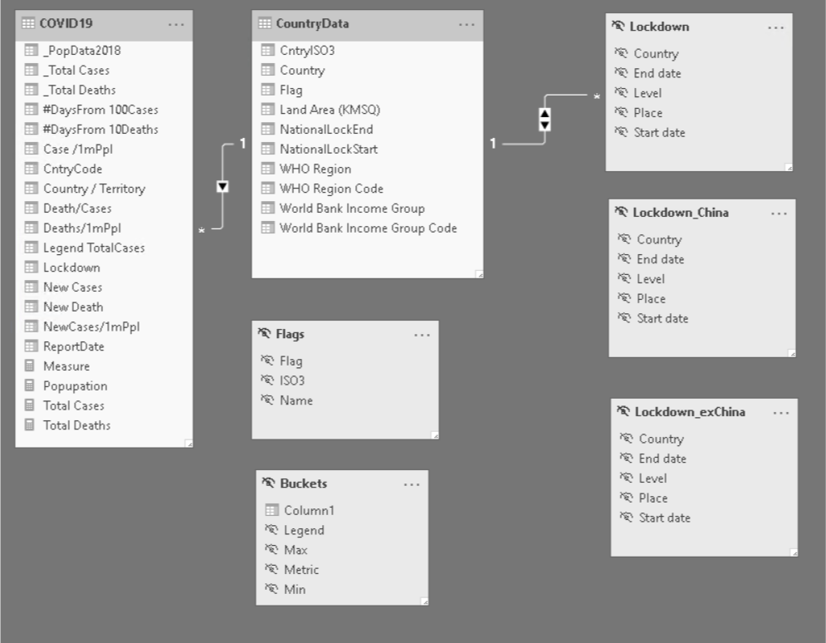

# Data Refresh

Use the refresh button on the home tab

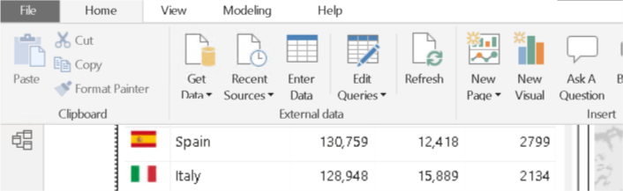

# Script Correction

Use the Edit Query mode to go to the power query editor to modify the underlying queries.

